Child of Light – Review

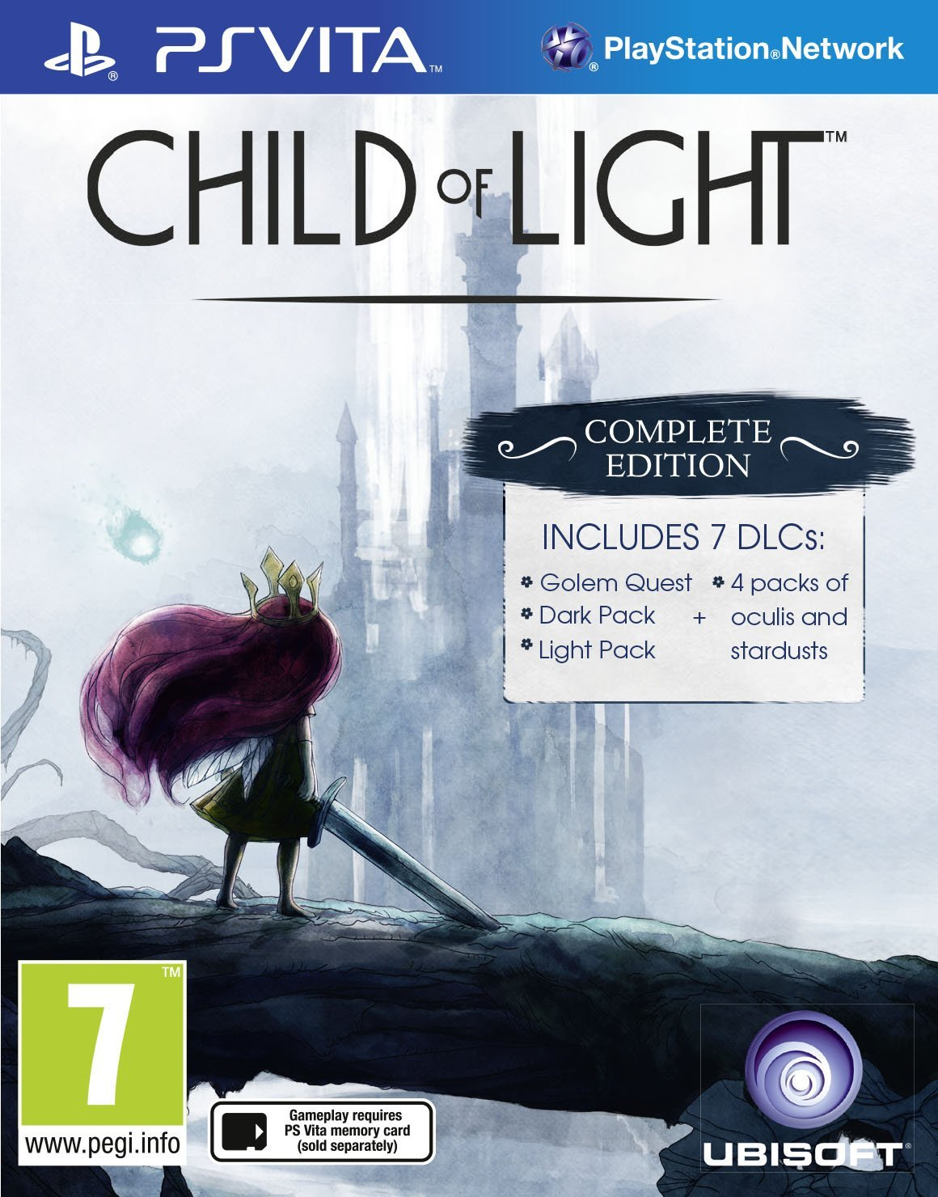

|  |
| --- |
| Year of Release: 2014  Publisher: Ubisoft  Developer: Ubisoft Montreal  Platforms: PC, PS4, PS3, PS Vita, Xbox 360, Xbox One |

Properties to research:

* Eternal Sonata
* Grandia
* Chrono trigger
* Rime of the ancient mariner
* Golden age of painting

Design

* Crafting
* Skill-trees
* Confessions
* Battle system

Moment-to-moment gameplay

* Flight
* Active time-battles

Presentation

* Music
  + The quality and how it affects the mood of the player
  + What the feel of the music does for the meaning
* Art
  + Water color painting
  + How the ubiart framework ids in the creation of the world and how it comes off

Narrative

The challenge is that Child of Light is two-fold. First off it wants to be a modern twist on the classic JRPG and secondly it wants to be an interactive fairytale fit for the entire family.

* The prose – influenced by rime of the ancient mariner.
* The overarching story – themes, characters